Project editor modes
Project editor has three modes: Edit, Run and Debug. The mode selection buttons (i.e. the Mode switcher) are located in the toolbar of the Project editor and will only be displayed if EEZ Flow is used in the project.
While the Dashboard project type includes EEZ Flow by default, for EEZ-GUI and LVGL projects it will be necessary to explicitly set whether or not to use EEZ Flow. To add EEZ Flow to such projects, use the Flow support option (Fig. 1).

Toolbar overview
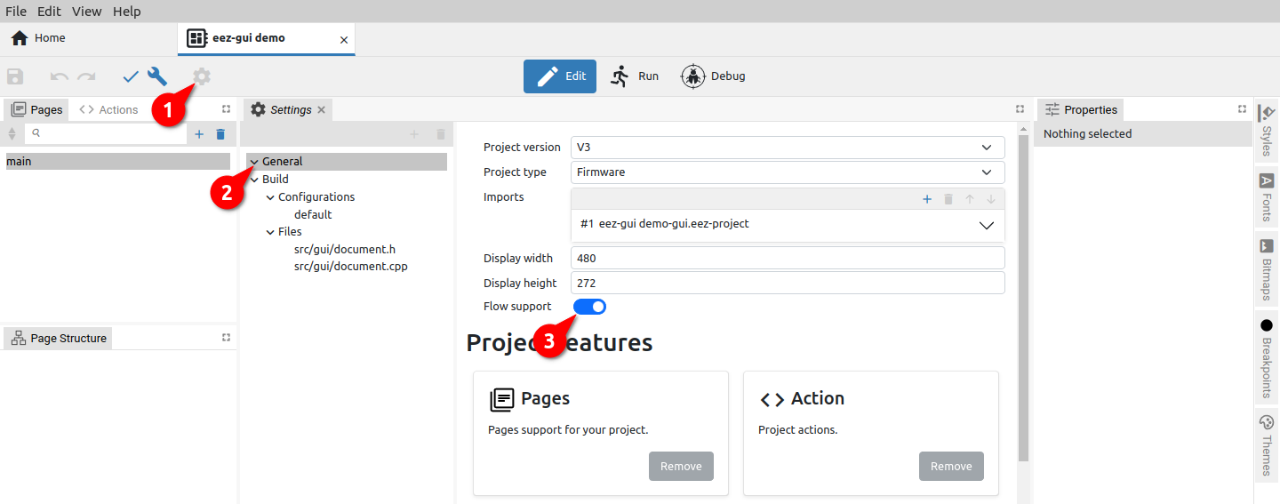Fig. 1: Enabling EEZ Flow in project Settings
The appearance of the Toolbar depends on the Project editor mode. Certain options are common to all modes, while some depend not only on the current mode but also on the selected Project features in Settings or the use of global variables when their status will be displayed.

Fig. 2 shows the toolbar with all options displayed. Their availability in each mode is shown in Table 1.

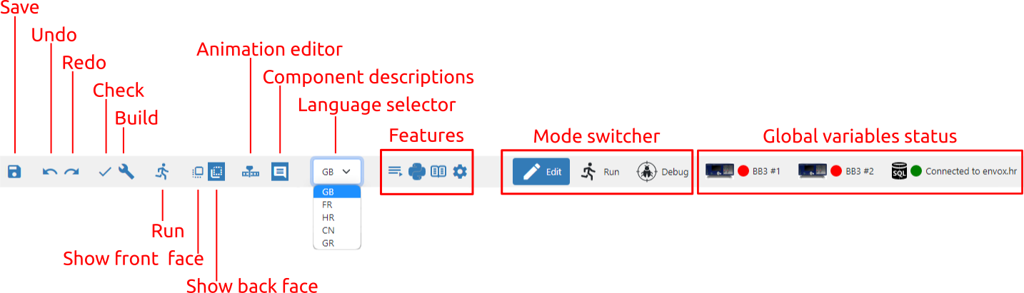Fig. 2: Project toolbar (all options)
What editors are in Edit mode, viewers are in Run and Debug mode. So we have Page viewer (in Run and Debug mode) and Action viewer (Debug mode only). For example, page viewer displays the page in the same way as the editor, but editing is not possible.

When the Project editor is in Run mode, it displays only the toolbar and the active page viewer.

In Run and Debug mode, it is not possible to change the project, but only to monitor the execution of the project.

Statuses of global variables are present only in Run or Debug mode and if the project has at least one global variable of type object, e.g. Instrument connection or PostgreSQL connection. Status shows icon, connection state (connected / disconnected) and title. By clicking on the status of the global variable, you can e.g. change the connected instrument or PostgreSQL connection parameters.
Function / Group | Edit | Run | Debug
Save | √
Undo | √
Redo | √
Check | √
Build | √
Run MicroPython Script (EEZ BB3 only) | √
Show front face | √ |  | √
Show back face | √ |  | √
Show / Hide animation timeline editor | √
Show / Hide component descriptions | √ |  | √
Language selector | √
Features | √
Mode switcher | √ | √ | √
Global variables status |  | √ | √

Table 1: Toolbar options in all modes

Toolbar in Edit mode
Undo / Redo
Undo / Redo recent editor Action. If any changes have been made to the project since the last save, a * sign will appear in the project tab next to the name (Fig. 3).

Check
Fig. 3: Indication of unsaved changes
All project elements are checked without building the executable code. The Results are displayed in the Output panel (Fig. 4).

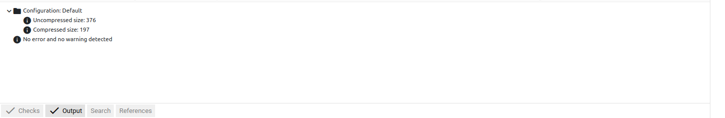Fig. 4: Results of project checking
Build
Build the executable code after checking all the elements of the project. The results are displayed in the Output panel (Fig. 5).

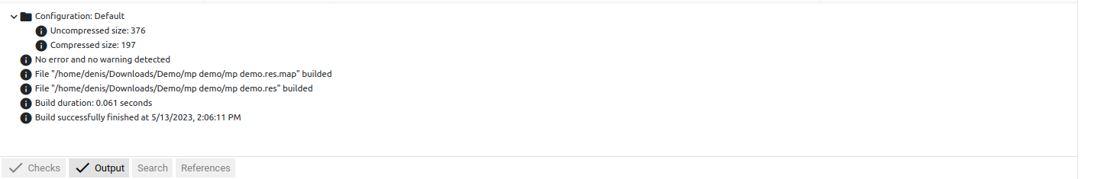Fig. 5: Project build results
Run MicroPython Script (EEZ BB3 only)

The option is available for a MicroPython Script type project that can be executed on an EEZ BB3 device. The MicroPython feature should also be selected in the project's general settings.

It starts the build of the project when the accompanying resource file (.res extension) is generated, which will be transferred together with the MicroPython script (.py extension) to the selected EEZ BB3 where it will be started.

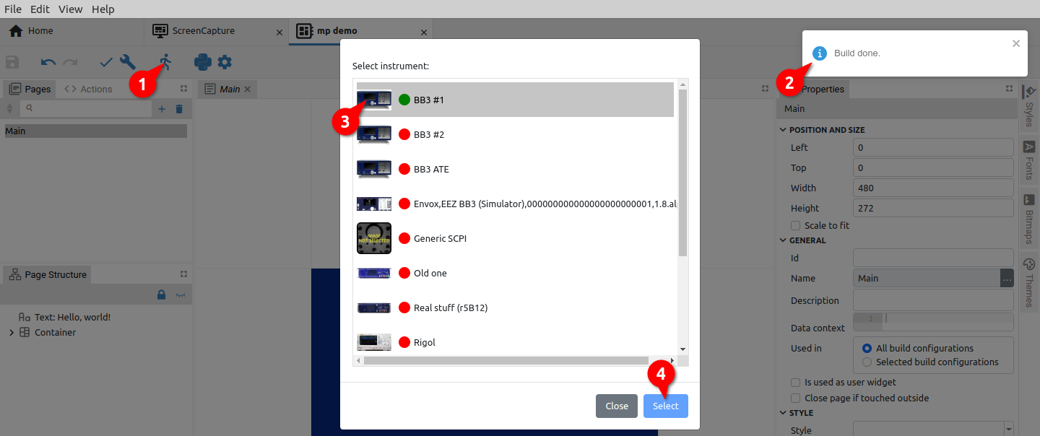Fig. 6: Selection of target EEZ BB3 for project execution
In case there is no active connection with the selected EEZ BB3, an additional dialog box for establishing the connection will appear. For example in Fig. 7 the serial interface is selected.

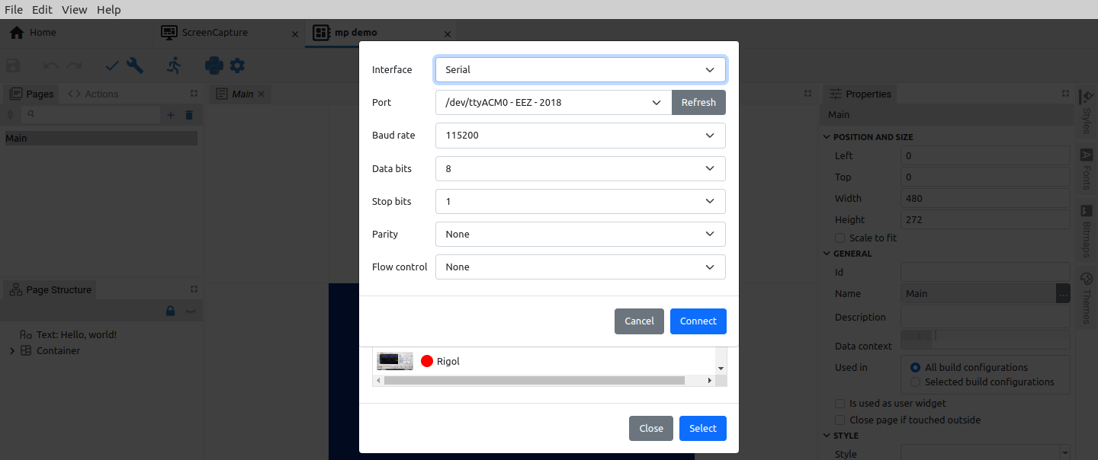Fig. 7: Selection of target EEZ BB3 for project execution
Finally, after the project files (.py and .res) have been successfully transferred to the selected EEZ BB3, an indication will appear when the MicroPython script has been started (Fig. 8).

Fig. 8: Project execution indication

Show front face
Shows only Widgets without Action components and lines in the page editor for better readability. This button is present if EEZ Flow is enabled in the project and if the page editor is in focus (Fig. 9).

Show back face
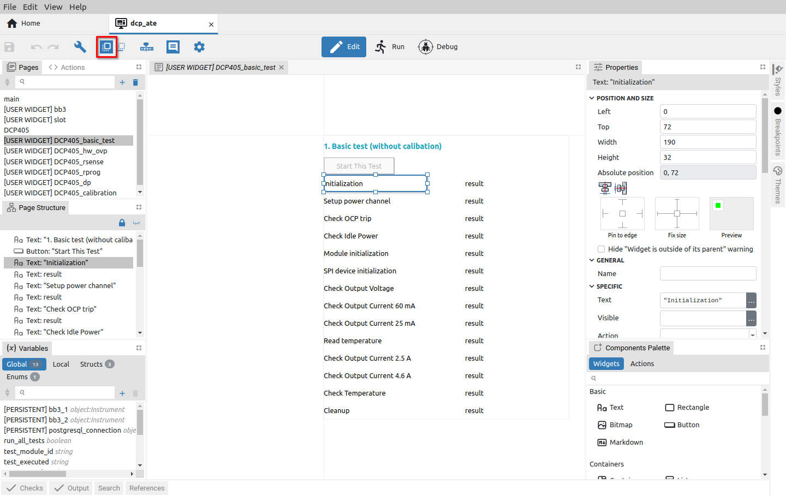Fig. 9: Project page in front face view
Shows all components (both Widgets and Actions) and lines in the page editor. This button is present if Flow is enabled in the project and if the page editor is in focus (Fig.10).

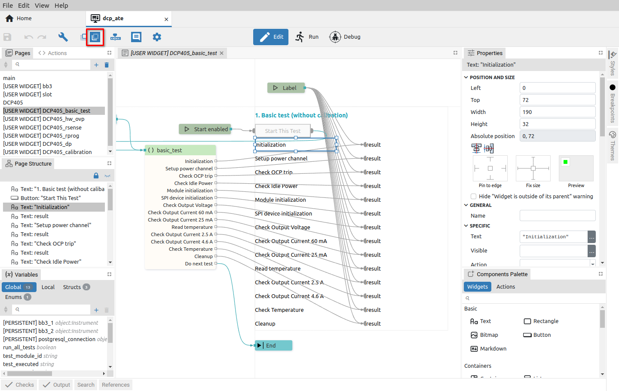Fig. 10: Project page in back face view
Show / Hide animation timeline editor
EEZ Flow supports animation of page content, for which the Animation timeline editor is used.

An icon in the toolbar to show and hide it will appear when the page editor is in focus. EEZ Flow should also be enabled in the general settings of the project (Fig. 1).

The animation timeline editor is displayed in the space below the page editor (Fig. 11).

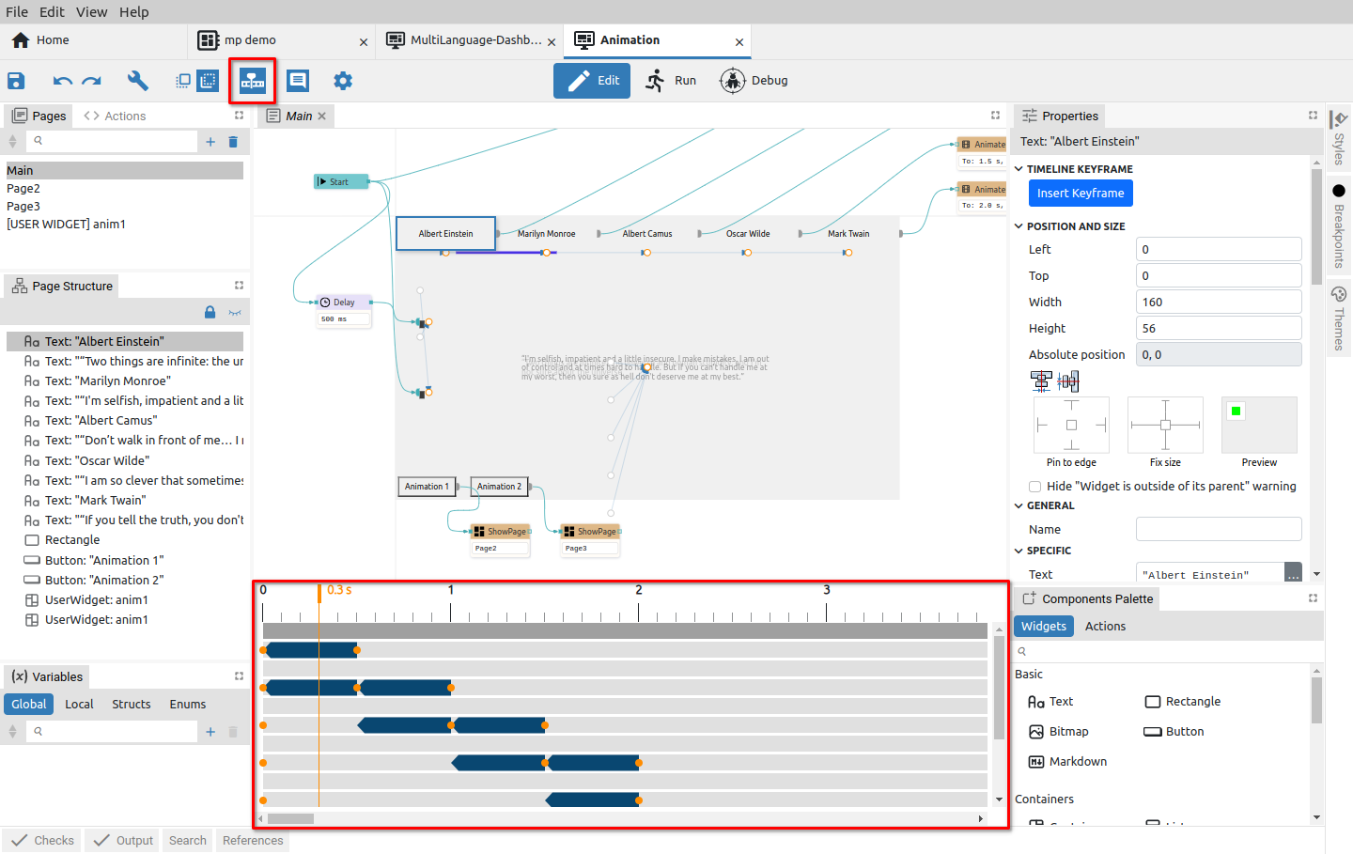Fig. 11: Project animation timeline editor
Show / Hide component descriptions
Each component has a Description property. With this option, we choose whether the description will be seen under the component or not (Fig. 12).

The option is only displayed if the page editor is in focus and Show back face is selected.

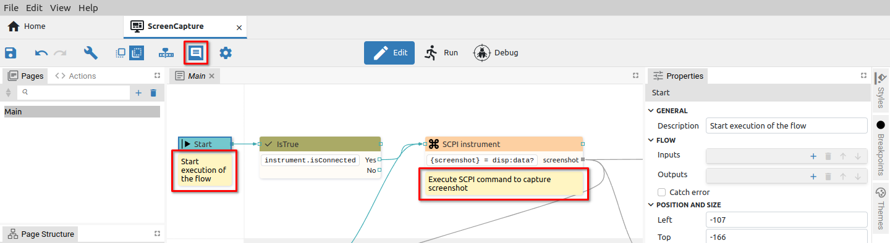Fig. 12: Component descriptions are visible

Language selector
This option is present in the toolbar if the Texts feature is selected in the project general settings and if at least one language is defined. Then the Texts tab will appear in the left border tabset (2), whose panel (3) contains definitions of multilingual text strings, used languages and translation statistics.
The texts displayed in the page editor will be displayed in the language selected in the language selector of the toolbar (1). In the example in Fig. 13 French (FR) is selected.

Feature buttons
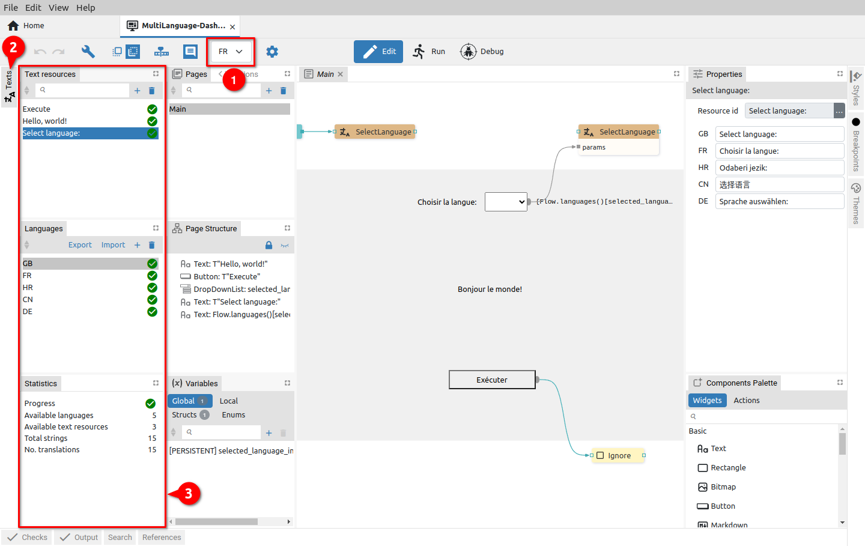Fig. 13: Project language selector
The following project features when selected in the project general settings will add an icon to the toolbar: Shortcuts, MicroPython and Readme. Project Settings also has its icon in the toolbar. The mentioned features, when selected, are displayed in the project editor as described in Chapter XX.

